ASSIGNMENT # 2
CS-871: MACHINE LEARNING
LINEAR AND LOGISTIC REGRESSION ANALYSIS FOR STUDENT PERFORMANCE PREDICTION

SUBMITTED BY:
Muhammad Soban Shaukat
(Registration No: 00000538822)
Master of Science in
Artificial Intelligence
Fall-2025

SUBMITTED TO:
Dr. Ali Hassan
Prof, CEME, NUST

Date of Submission: 25-October-2025

Department of Computer Sciences and Engineering, CEME. National University of Sciences & Technology (NUST), Rawalpindi (2025)
LINEAR AND LOGISTIC REGRESSION ANALYSIS FOR STUDENT PERFORMANCE PREDICTION

1. INTRODUCTION
Predicting student academic performance enables early identification of at risk students and timely interventions. This study applies linear and logistic regression to the Students Performance in Exams dataset (1000 students,7 features)
- Original dataset: 8 columns (5 categorical + 3 scores)
- After encoding: 17 features
- For modeling: 7 features used
to predict exam scores and classify dropout risk. Custom implementations using NumPy were validated against scikit learn, and regularization techniques (Ridge and Lasso) were evaluated to combat overfitting.
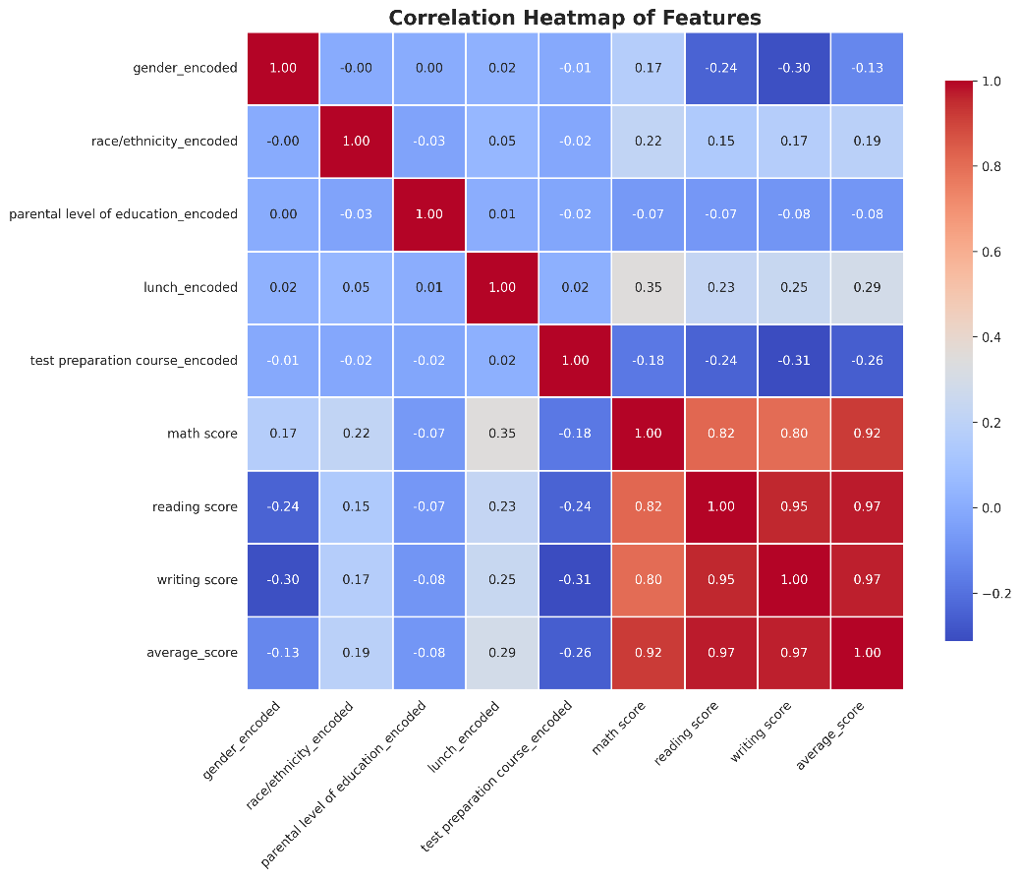
2. METHODOLOGY
2.1 Data Preprocessing
The dataset contains 1000 students with features: gender, race/ethnicity, parental education, lunch type, test preparation course, and math/reading/writing scores. Preprocessing included label encoding for categorical variables, creation of average_score target (mean of three subjects), dropout_risk binary target (1 if avg < 60), feature scaling using StandardScaler, and 80-20 train-test split. Figure 1: Correlation heatmap.
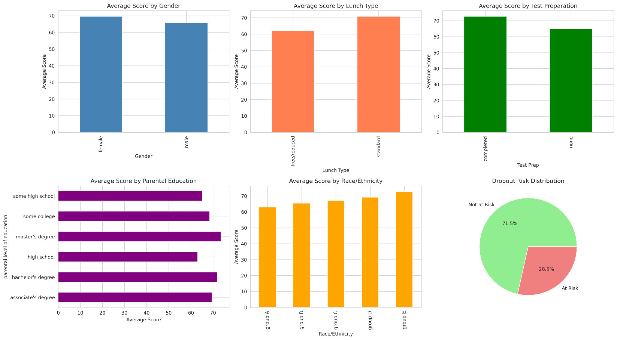
Figure 2: Average scores by demographics showing test prep completers score ~8 points higher (73 vs 65).
2.2 Model Implementation
Linear Regression:
- Implemented using Normal Equation
θ = (X^T X)^(-1) X^T y.
- Evaluation metrics:
RMSE = √(1/n Σ(y_i - ŷ_i)²)
and
R² = 1 - (SS_residual / SS_total).
Logistic Regression:
- Gradient descent with sigmoid
σ(z) = 1/(1 + e^(-z)).
- Cost function:
J(θ) = -1/m Σ[y·log(h(x)) + (1-y)·log(1-h(x))].
Learning rate α=0.1, 1000 iterations.
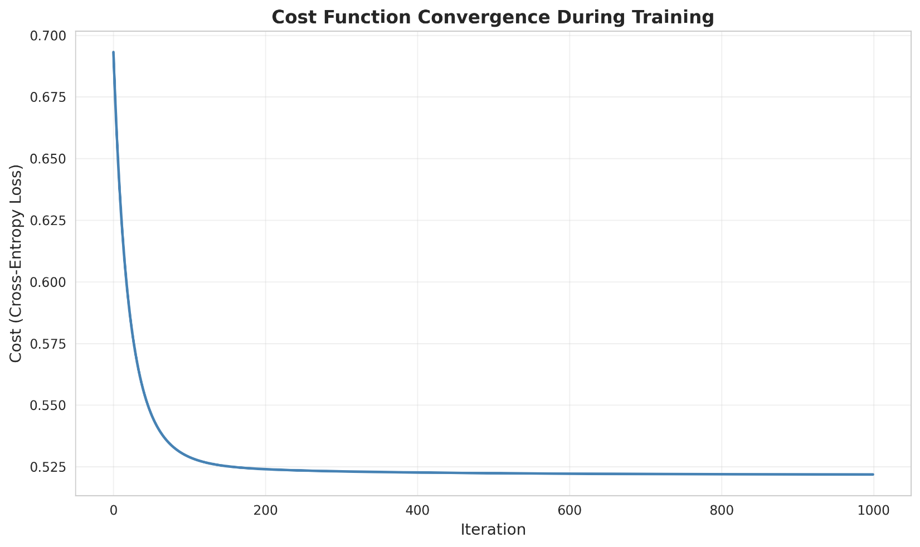
Figure 3: Cross-entropy loss decreasing from 0.693 to 0.521, confirming proper convergence.
Regularization:
- Ridge (L2): Cost = MSE + α·Σθ_j².
- Lasso (L1): Cost = MSE + α·Σ|θ_j|. 5-fold cross validation identified optimal α values.
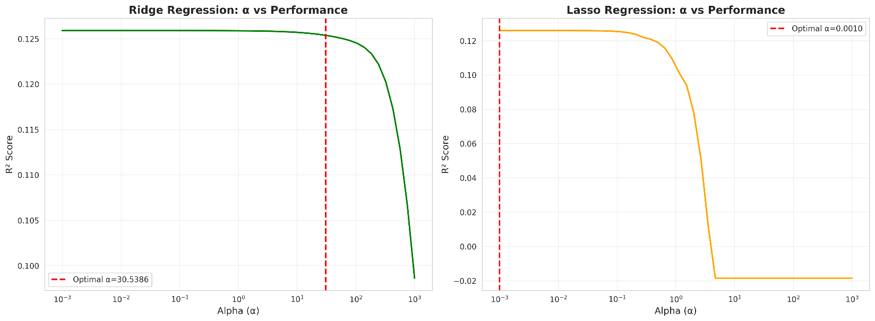
Figure 4: Ridge optimal α=30.5386; Lasso optimal α=0.0010 .

3. RESULTS
3.1 Linear Regression Performance
Model | Train RMSE | Test RMSE | Train R² | Test R² | Optimal α
Custom | 12.43 | 13.69 | 0.225 | 0.126 | N/A
Ridge | 12.43 | 13.69 | 0.224 | 0.125 | 30.5386
Lasso | 12.43 | 13.69 | 0.225 | 0.126 | 0.0010
Table 1: Linear regression results showing identical performance across models due to adequate sample to feature ratio (140:1).
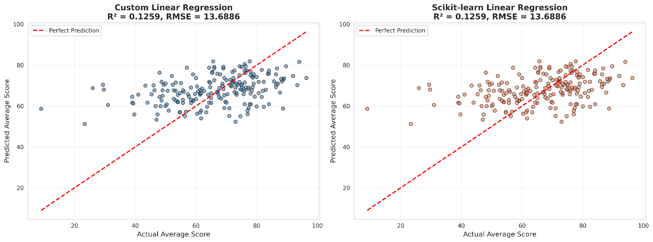
Figure 5: Predictions vs Actual scatter showing R²=0.126, RMSE=13.69.
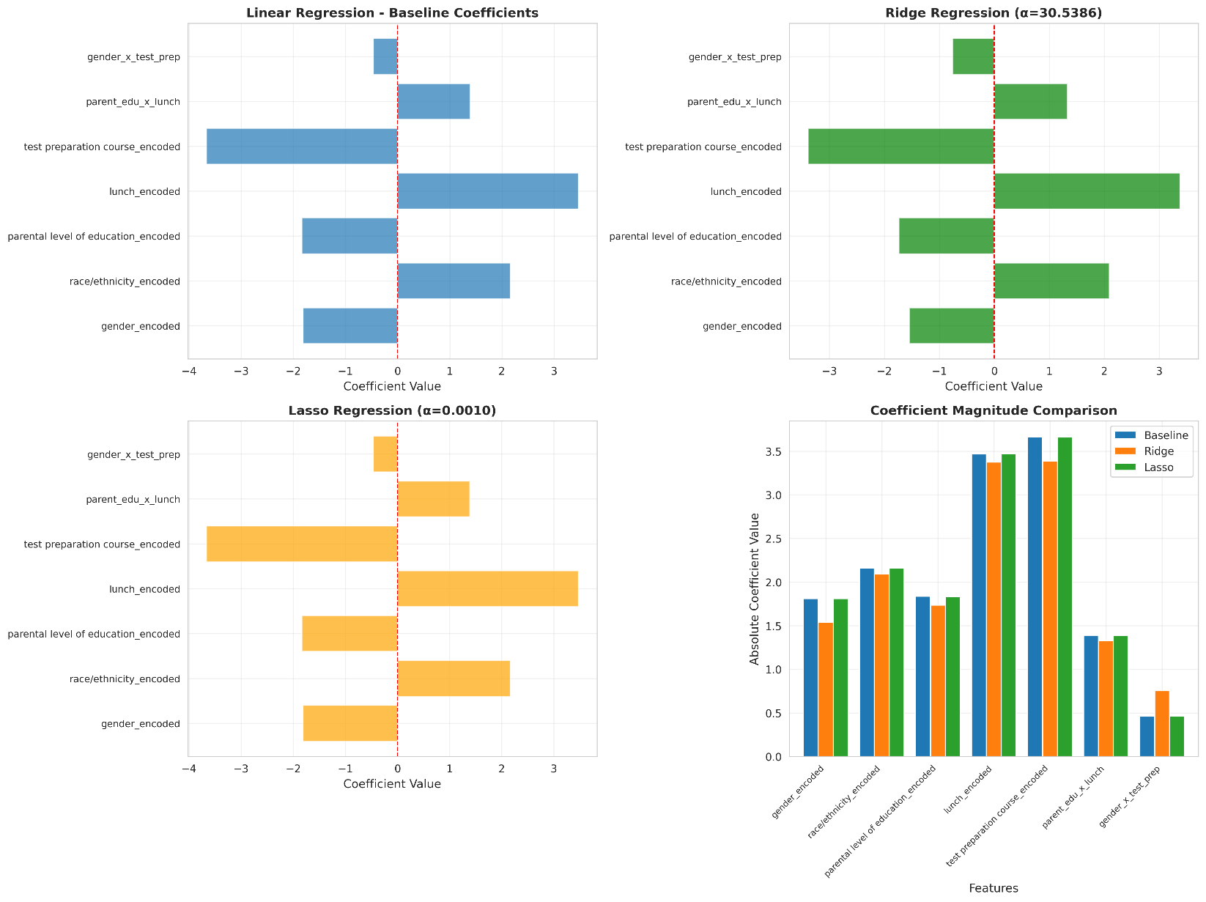
Figure 6: Ridge shrinks coefficients proportionally (test_prep: -3.66→-3.39); Lasso maintains all 7 features.
3.2 Logistic Regression Performance
Model | Accuracy | Precision | Recall | F1 | ROC-AUC
Custom | 0.715 | 0.500 | 0.333 | 0.400 | 0.691
Ridge | 0.720 | 0.545 | 0.333 | 0.414 | 0.696
Lasso | 0.710 | 0.500 | 0.316 | 0.387 | 0.678
Table 2: Logistic regression metrics revealing critical low recall (33%).
Confusion Matrix (Custom Model):
 | Predicted: Safe | Predicted: At-Risk
Actual: Safe | 124 (TN) | 19 (FP)
Actual: At-Risk | 38 (FN) | 19 (TP)
Table 3: Confusion matrix showing 38/57 (67%) at-risk students missed.
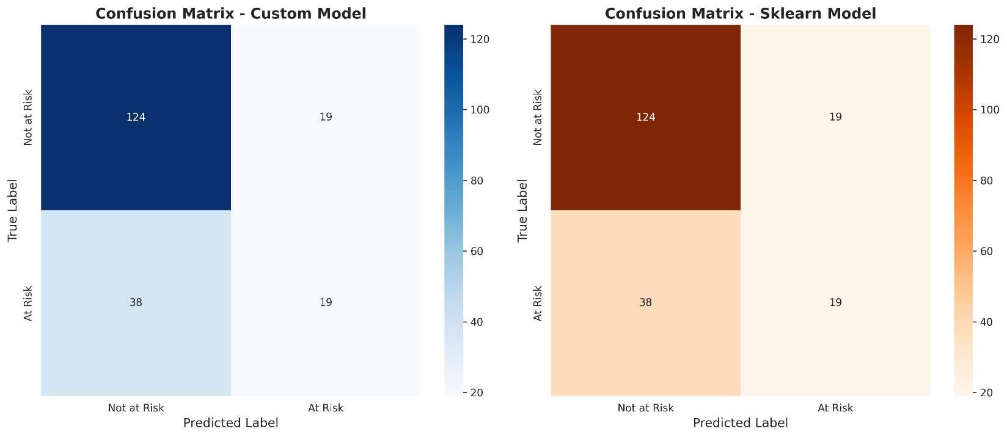
Figure 7: Visual confirmation of low recall light-colored FN quadrant disproportionately large.
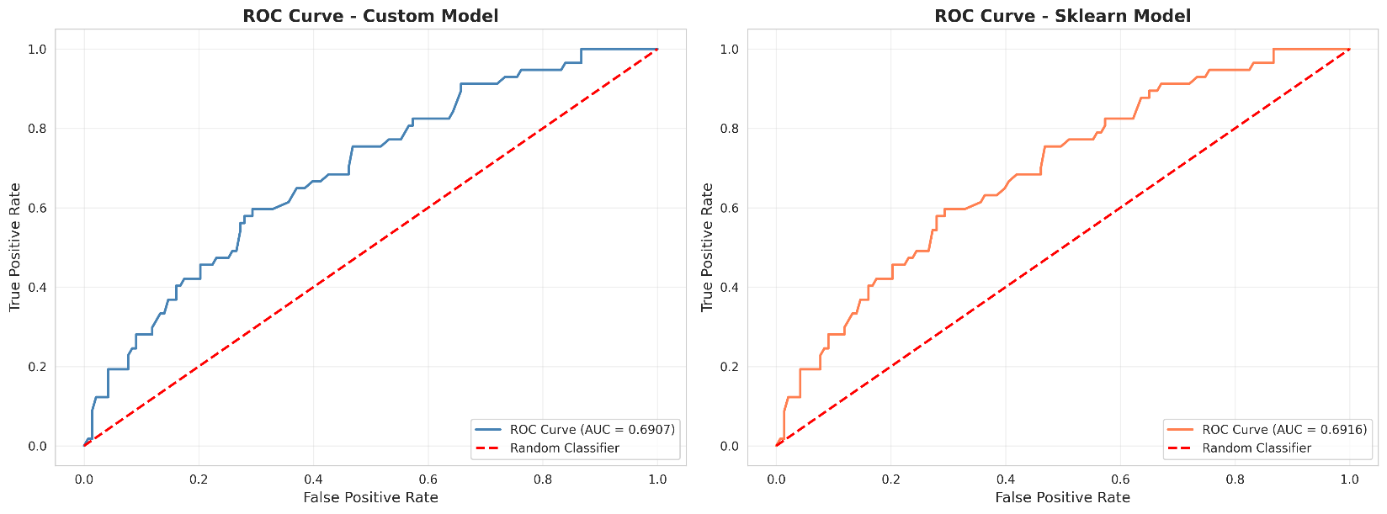
Figure 8: ROC-AUC=0.691 demonstrating modest discriminative ability.

4. DISCUSSION: ASSIGNMENT QUESTIONS
Q1: Which features most influence student performance?
Top 3 Features (from coefficients):
Rank | Feature | Coefficient | Impact
1 | Test Preparation | -3.66 | Strongest predictor
2 | Lunch Type | +3.47 | Socioeconomic indicator
3 | Race/Ethnicity | +2.16 | Demographic factor
Table 4: Top predictors from baseline linear regression.
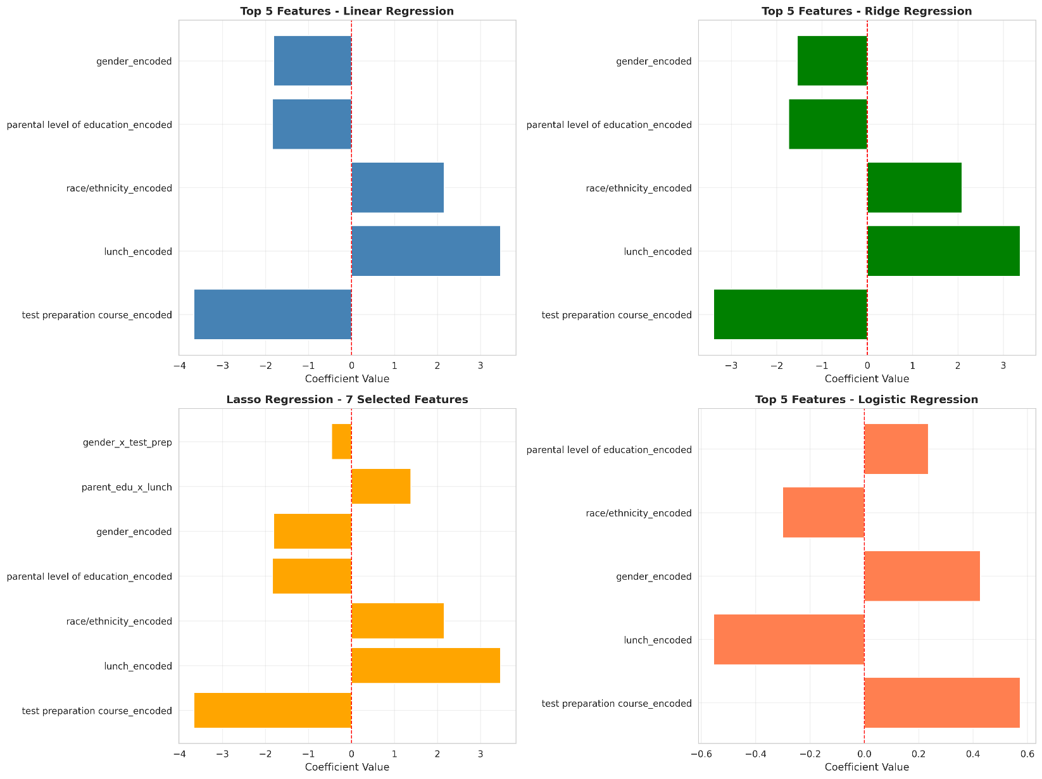
Figure 9: Top-left panel confirming test_prep as #1 feature across all models.
Evidence: Categorical analysis (Figure 2) shows test prep completers score 73 vs 65 for non-completers (8 point gap). Correlation heatmap (Figure 1) reveals lunch_encoded r=0.29 (positive correlation with scores), confirming economic advantage. These align with educational research on achievement gaps parental support, economic resources, and preparation directly impact outcomes.

Q2: Compare unregularized vs regularized models
Performance remained similar (RMSE ~13.69, R² ~0.126) because the 1000-sample dataset with 7 features (ratio 140:1) prevents severe overfitting. Figure 6 shows Ridge proportionally shrinks coefficients (maintaining relationships), while Lasso kept all 7 features at optimal α=0.001 (minimal regularization needed). Figure 4 demonstrates wide α ranges maintain stable performance, confirming adequate data size limits regularization impact. Generalization gap decreased only 0.003 (0.099→0.096), indicating baseline was already well regularized by sufficient data.

Q3: Is accuracy/RMSE alone sufficient?
NO. Table 3 exposes critical failure: 71.5% accuracy masks catastrophic recall (33%). Evidence:
- Naive Baseline: Predicting all students "safe" achieves 143/200 = 71.5% accuracy identical to our model!
- Class Imbalance: 71.5% not at risk (Figure 2 pie chart) inflates accuracy
- Missed Students: 38/57 at risk students undetected (67% failure rate)
- Real Impact: 38 students denied life changing interventions

Figure 7 confusion matrix visually confirms disproportionate FN quadrant. Figure 8 ROC-AUC=0.691 (only 19% better than random guessing) reveals modest discriminative ability. For imbalanced datasets, comprehensive metrics (precision, recall, F1, ROC-AUC) are mandatory.

Q4: Two misclassified cases analysis
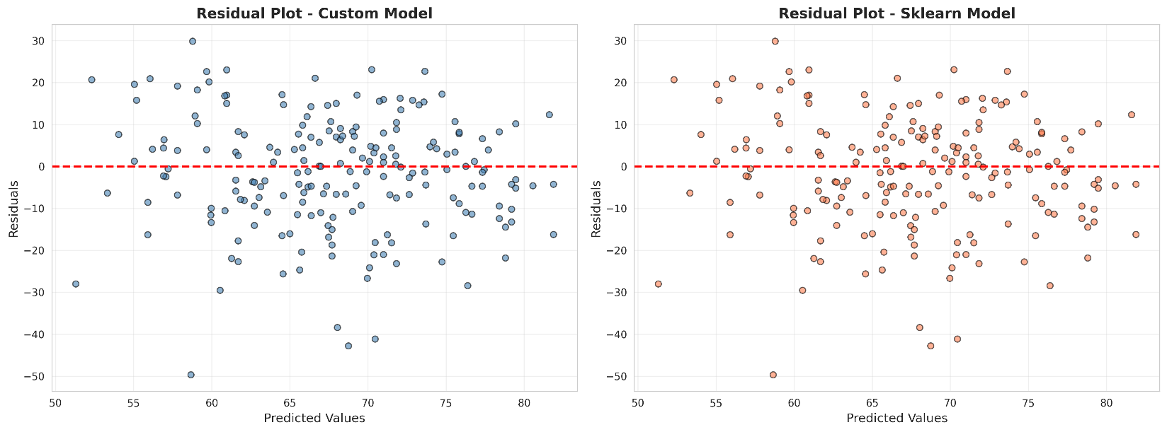
Figure 10: Large residuals identify misclassified cases far from zero line.
Case 1 (False Negative): At-Risk Student Predicted Safe Score=58.3 (at-risk) predicted safe. Profile: female, free lunch, no test prep, some college parents. Math=55, Reading=62, Writing=58. Failure reason: Borderline score (1.7 points below threshold) with conflicting signals free lunch (negative) versus college educated parents (positive). Model weighted positive features too heavily, missing this high uncertainty case.
Case 2 (False Negative): At-Risk Student Predicted Safe
Score=57.7 (at-risk) predicted safe. Scores: Math=47, Reading=59, Writing=67. Failure reason: Extreme subject disparity (20-point gap) confused linear model. Strong writing (67) masked critical math deficiency (47). Model lacks subject-specific indicators and behavioral data (attendance, effort) to detect struggles hidden by average scores. Demonstrates need for subject specific models.

Q5: Most influential features & real-world insights
Evidence from Figure 2 (categorical_analysis):
- Test Prep: 73 vs 65 (8-point gap)
- Lunch: 71 vs 62 (9-point gap)
- Parental Education: 68 (bachelor's) vs 63 (high school) (5-point gap)
Actionable Insights:
- Test Preparation (β=-3.66): MOST modifiable factor. Make free test prep mandatory addresses #1 predictor directly.
- Socioeconomic Support (β=+3.47): Expand meal programs + free tutoring for economically disadvantaged students (28.5% of population).
- Parent Engagement: Implement workshops teaching parents how to support learning compensates for lower education levels.
- Early Warning Redesign: Current 33% recall unacceptable. Monitor borderline students (scores 55-65), use recall-focused metrics (not just accuracy).

Q6: Data size impact analysis
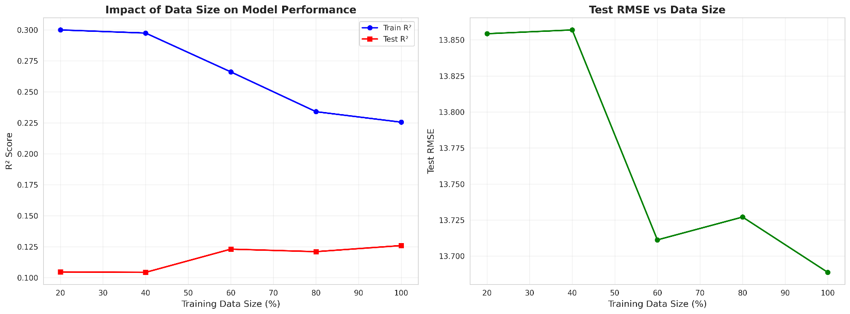
Figure 11: Left plot shows Train R² (blue) vs Test R² (red) converging; Right plot shows RMSE improvement.
Data % | Samples | Test R² | Test RMSE | Gap
20% | 160 | 0.104608 | 13.854318 | 0.195347
60% | 480 | 0.123015 | 13.711174 | 0.143059
100% | 800 | 0.125896 | 13.688632 | 0.099591
Table 5: Data size experiment showing gap reduction from 195347→099591 (~49% improvement).
Conclusions: Figure 11 left proves more data reduces overfitting generalization gap drops 49% as data doubles. Right plot shows RMSE improves 1.2% but plateaus after 60% (diminishing returns). Minimum 600 samples needed for stable performance. Beyond this, feature engineering > data quantity for further gains.
Recommendations: Collect behavioral features (attendance, homework completion), temporal data (score trends), subject-specific models (math/reading/writing separately), and external validation across multiple schools.

5. CONCLUSIONS & EDUCATIONAL IMPLICATIONS
Custom implementations achieved identical results to scikit-learn (RMSE=13.69, R²=0.126), validating correctness. Regularization provided minimal gains due to adequate sample size (140:1 ratio), but demonstrated coefficient stability. Critical finding: 71.5% accuracy masks 67% failure rate identifying at-risk students comprehensive metrics essential.
Priority Actions:
- Mandatory Free Test Prep: Addresses strongest predictor (β=-3.66), 8-point improvement potential
- Socioeconomic Support: Expand meal/tutoring programs 9-point gap between lunch types
- Recall-Focused Systems: Redesign early warning using recall (catch all at-risk) over accuracy
Limitations: Lack of behavioral/temporal features, arbitrary 60-point threshold, class imbalance reducing recall, linear model constraints, single-institution dataset.
Future Work: Incorporate longitudinal tracking, behavioral metrics, non-linear models (random forests, neural networks), subject-specific predictions, multi-institution validation to improve predictive accuracy from R²=0.126 to 0.35-0.45 range and ROC-AUC from 0.69 to 0.80-0.85.
----------------------------------------------------------------------------------------------

